“Build Your Own Terabithia” Project
“We need a place just for us, it would be so secret that no one in the world would know about it” - Leslie Burke

At some point, we have all wished that we could have a secret place that was all our own. In Bridge to Terabithia, Jess and Leslie get the opportunity to create a secret world using their imaginations, and now you will too! Your project is simple, you are to create your own Terabithia in any way that you imagine it. You could make a 3D model out of Lego, draw pictures, make a book, or use Minecraft, the possibilities are endless! Once your model is complete, you are to do a write-up of everything that we would find in your Personal Terabithia. Make sure to follow the success criteria checklist, and most of all, have fun!!

Here are some guidelines to help you in creating your project and writing your paper:
● Where will your Terabithia be located? In the woods? By the beach? in your own backyard? There are many choices, just make sure it is possible (ex. no clouds, or underwater cities)
● What does your castle stronghold look like? Is it a fort? a treehouse? a castle? What is it made out of?
● What types of creatures live there? (ex. dragons, fairies, trolls, or something completely new that you made up)
● What are some of the dangers in your Terabithia? What evil rulers may be trying to attack? How will you protect yourself from these attacks? (magic, weapons, brains)
● How do you enter your land? Is it a rope like Terabithia, or a magical road or door, or something else?
● Who will take over your land when you can no longer rule? Who will be King/Queen, Prince/Princess with you? How will God and faith fit into your land?
● What is the name of your land?
● How does your land differ from Jesse’s and Leslie’s Terabithia? How is it the same? (use specific examples from the text to explain)

Learning Goal: To create my own Terabithia and to describe it and explain in detail how it compares to Terabithia in the novel

Success Criteria
- I can show that I understand what Terabithia meant to Jess and Leslie.
- I understand what Terabithia looked like.
- I can create my own Terabithia and represent it visually.
- I can describe my Terabithia in detail.
- I can explain how it is different and similar to Terabithia in the book.
- I can write my ideas clearly in a report.
- I can use my time wisely and balance the time I spend doing creative work and the time I spend writing so that I can finish both on time.
- I can follow the rules of Minecraft if I choose that format (ex. Use my own name, not enter anyone else’s world without permission, not destroy anything)

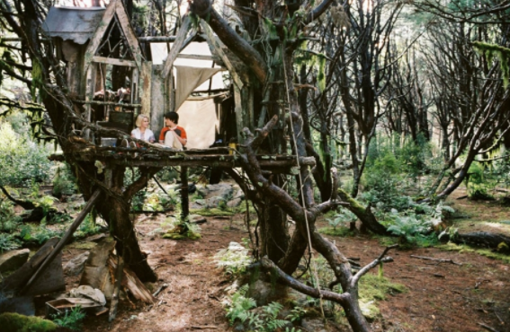

Personal Terabithia
Name_______________________________________________________

Expectations | Level 1 | Level 2 | Level 3 | Level 4
Reading  1. read and demonstrate an understanding of a variety of literary, graphic, and informational texts, using a range of strategies to construct meaning | Student shows limited ability to understand the importance of Terabithia in the novel | Student shows some ability to understand the importance of Terabithia in the novel | Student shows considerable ability to understand the importance of Terabithia in the novel | Student shows excellent ability to understand the importance of Terabithia in the novel in detail
Reading  1.6 extend understanding of texts by connecting the ideas in them to their own knowledge, experience, and insights, to other familiar texts, and to the world around them | Student shows limited ability to create a personal Terabithia that is meaningful to them and to compare it to the world in the novel. | Student shows some ability to create a personal Terabithia that is meaningful to them and to compare it to the world in the novel. | Student shows considerable ability to create a personal Terabithia that is meaningful to them and to compare it to the world in the novel. | Student shows excellent ability to create a detailed personal Terabithia that is meaningful to them and to compare it to the world in the novel.
Writing  1.5 identify and order main ideas and supporting details and group them into units that could be used to develop several linked paragraphs, using a variety of strategies | Student shows limited ability to write complete, organized paragraphs. | Student shows some ability to write complete, organized paragraphs. | Student shows considerable ability to write complete, organized paragraphs. | Student shows excellent ability to write complete, organized paragraphs.
Writing  2.3 use some vivid and/or figurative language and innovative expressions to add interest 3.1 spell familiar words correctly  3.4 use punctuation appropriately to help communicate their intended meaning | Student shows limited ability to choose vivid words, spell word correctly and use proper punctuation. | Student shows some ability to choose vivid words, spell word correctly and use proper punctuation. | Student shows considerable ability to choose vivid words, spell word correctly and use proper punctuation. | Student shows excellent ability to choose vivid words, spell word correctly and use proper punctuation.
Art  D1.1 create two- and three-dimensional art works that express feelings and ideas inspired by their own and others’ points of view | Student shows limited ability to create a 3 dimensional imaginary world | Student shows some ability to create a 3 dimensional imaginary world | Student shows considerable ability to create a 3 dimensional imaginary world | Student shows excellent ability to create a detailed 3 dimensional imaginary world

Personal Terabithia Self-Assessment Checklist
(To be handed in with report)

Name_________________________________________________

❑ I have written about one page (250 words, 12 font, single spaced)
❑ I have at least one paragraph that describes my world in detail (features I chose, protection and survival features, who can live there, name, location, etc.)
❑ I have used descriptive language
❑ I have checked spelling
❑ I have compared my Terabithia with the one in the novel and explained how it is the same and different

The best part of my work is

The hardest part of this work was

