Grade 5 Term 2 Science – Properties of and Changes in Matter

Big Ideas:
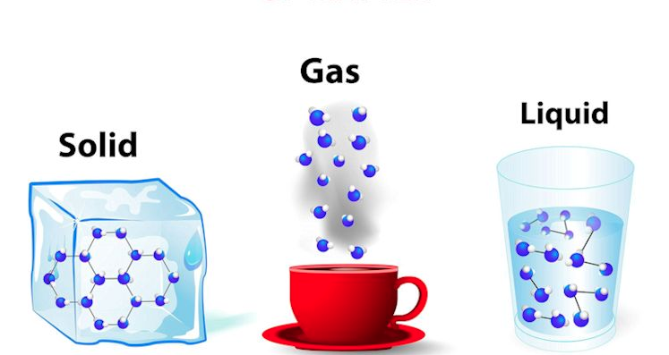
1. There are three states of matter.
2. Matter that changes state is still the same matter.
3. Physical change refers to the fact that a substance can be changed from one form to another.
4. Chemical change implies the formation of a new substance.
5. The properties of materials determine their use and may have an effect on society and the environment.
Success Criteria:
1. I can evaluate the social and environmental impacts of processes used to make everyday products
2. I can conduct investigations that explore the properties of matter and changes in matter
3. I can demonstrate an understanding of the properties of matter, changes of state, and physical and chemical change.

Consumable Product Research Project

Your task: Have you ever wondered how a product is made? You will research a consumable product (food, school supply, sports equipment, household products, etc. as long as it’s designed to be used for a relatively short amount of time). You will create a poster or pamphlet that shows what natural materials are used to make your product and how they are changed in the manufacturing process. You will then give your opinion about the environmental impact of the manufacturing, use and disposal of your product.

Learning Goal: We will demonstrate an understanding of the three states of matter and the changes in state that occur throughout the manufacturing process.

Success Criteria:

-I can identify the natural materials used to manufacture my product

-I can describe the steps required to modify the natural materials to make my product

-I can identify what causes the changes of matter during the manufacturing process

-I can identify and describe the physical and chemical changes of matter during the manufacturing process

-I can use the appropriate science and technology vocabulary

-I can make my poster/pamphlet visually appealing to the reader

-I can accurately record all of the resources I used (3-5)

-I can explain the environmental impact of the manufacturing process of my product

Pamphlet/ Poster Details

Remember that a consumable product is one that is designed to be used and thrown away in a fairly short amount of time.

Headings

Product: What is the product you have chosen and what is it used for?

Natural materials: What are the resources that go into the making of the product (ex. Minerals, wood, wheat, oil, etc.)?

Changes: What are the changes in states of matter that occur (ex. Solid, liquid, gas)

How is it made: Describe briefly how the product is made

Environmental impact: Think of every stage of this product’s development and how that can impact the environment (ex. In a pencil, trees are cut down for the wood, which affects animal habitats and oxygen production, the factory where they are made uses electricity and creates pollution, the trucks that deliver the pencils cause pollution, then the pencils are often thrown away, which creates more garbage.)

